[System Calls and Device Drivers](http://eslinuxprogramming.blogspot.com/2015/07/system-calls-and-device-drivers.html)

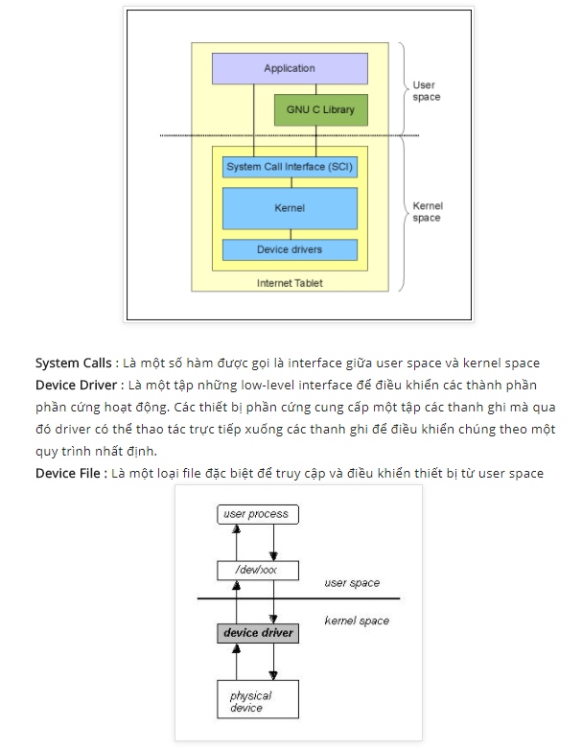

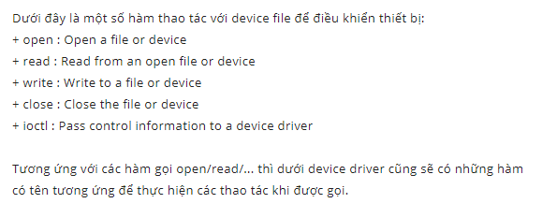

## [Device driver, device file](http://eslinuxprogramming.blogspot.com/2015/06/device-driver-device-node.html)

